# 韩昊辰 学术英语写作001班

12，13周个人学习档案袋

# Week 12

**1, My learning**

* 1. Mind map of group presentation

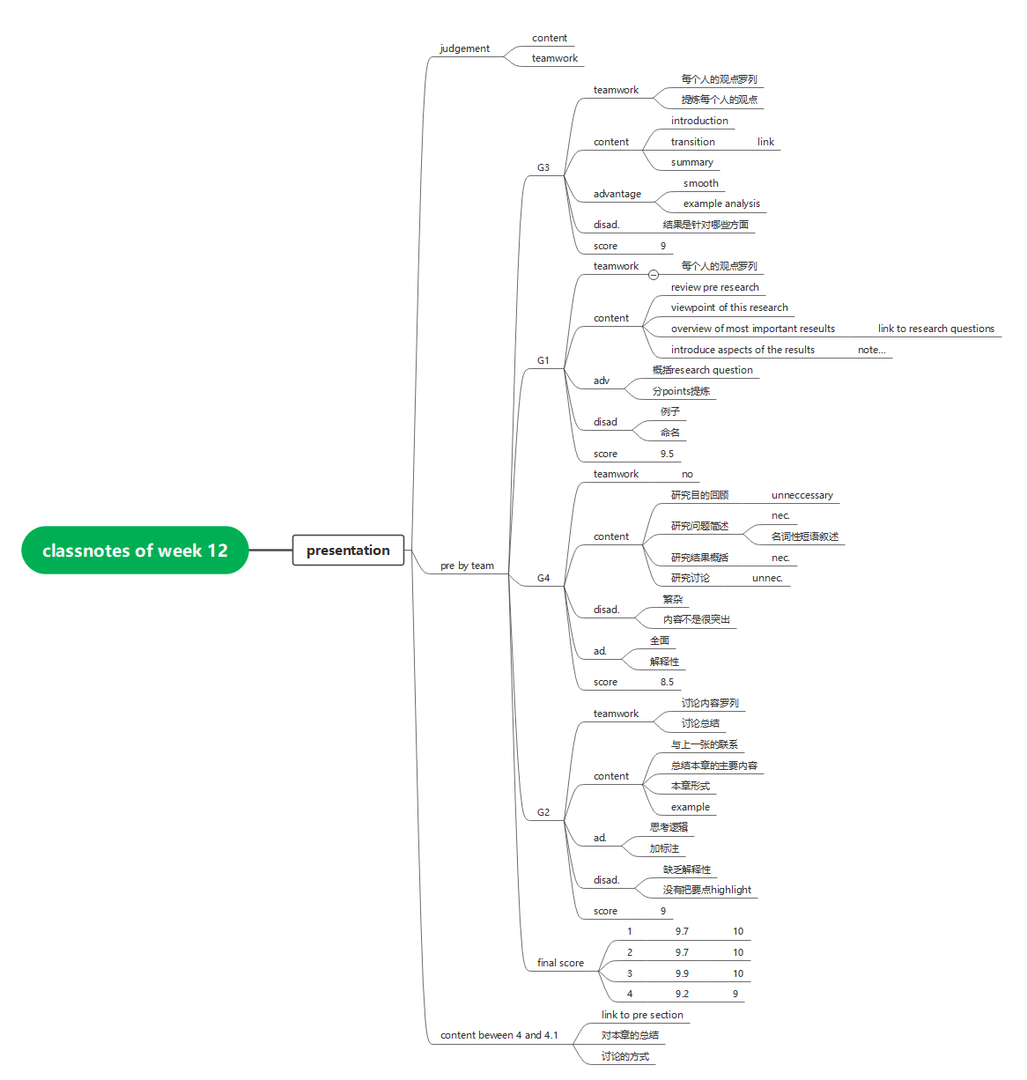

* 1. Mind map of class notes of conclusion

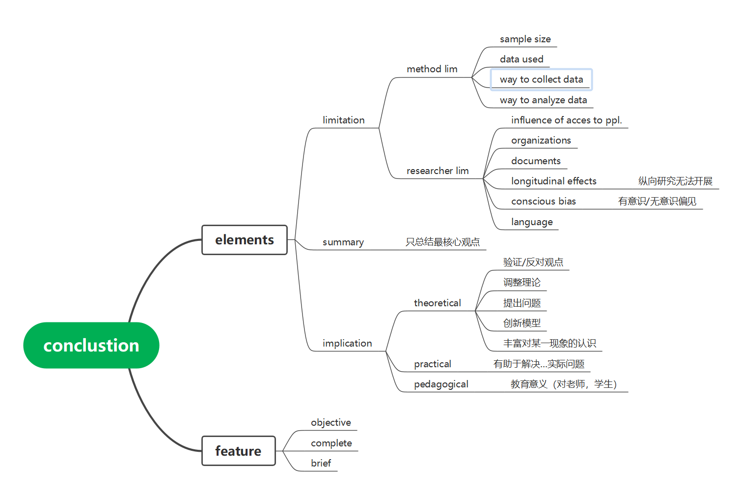

* 1. Write conclusion section

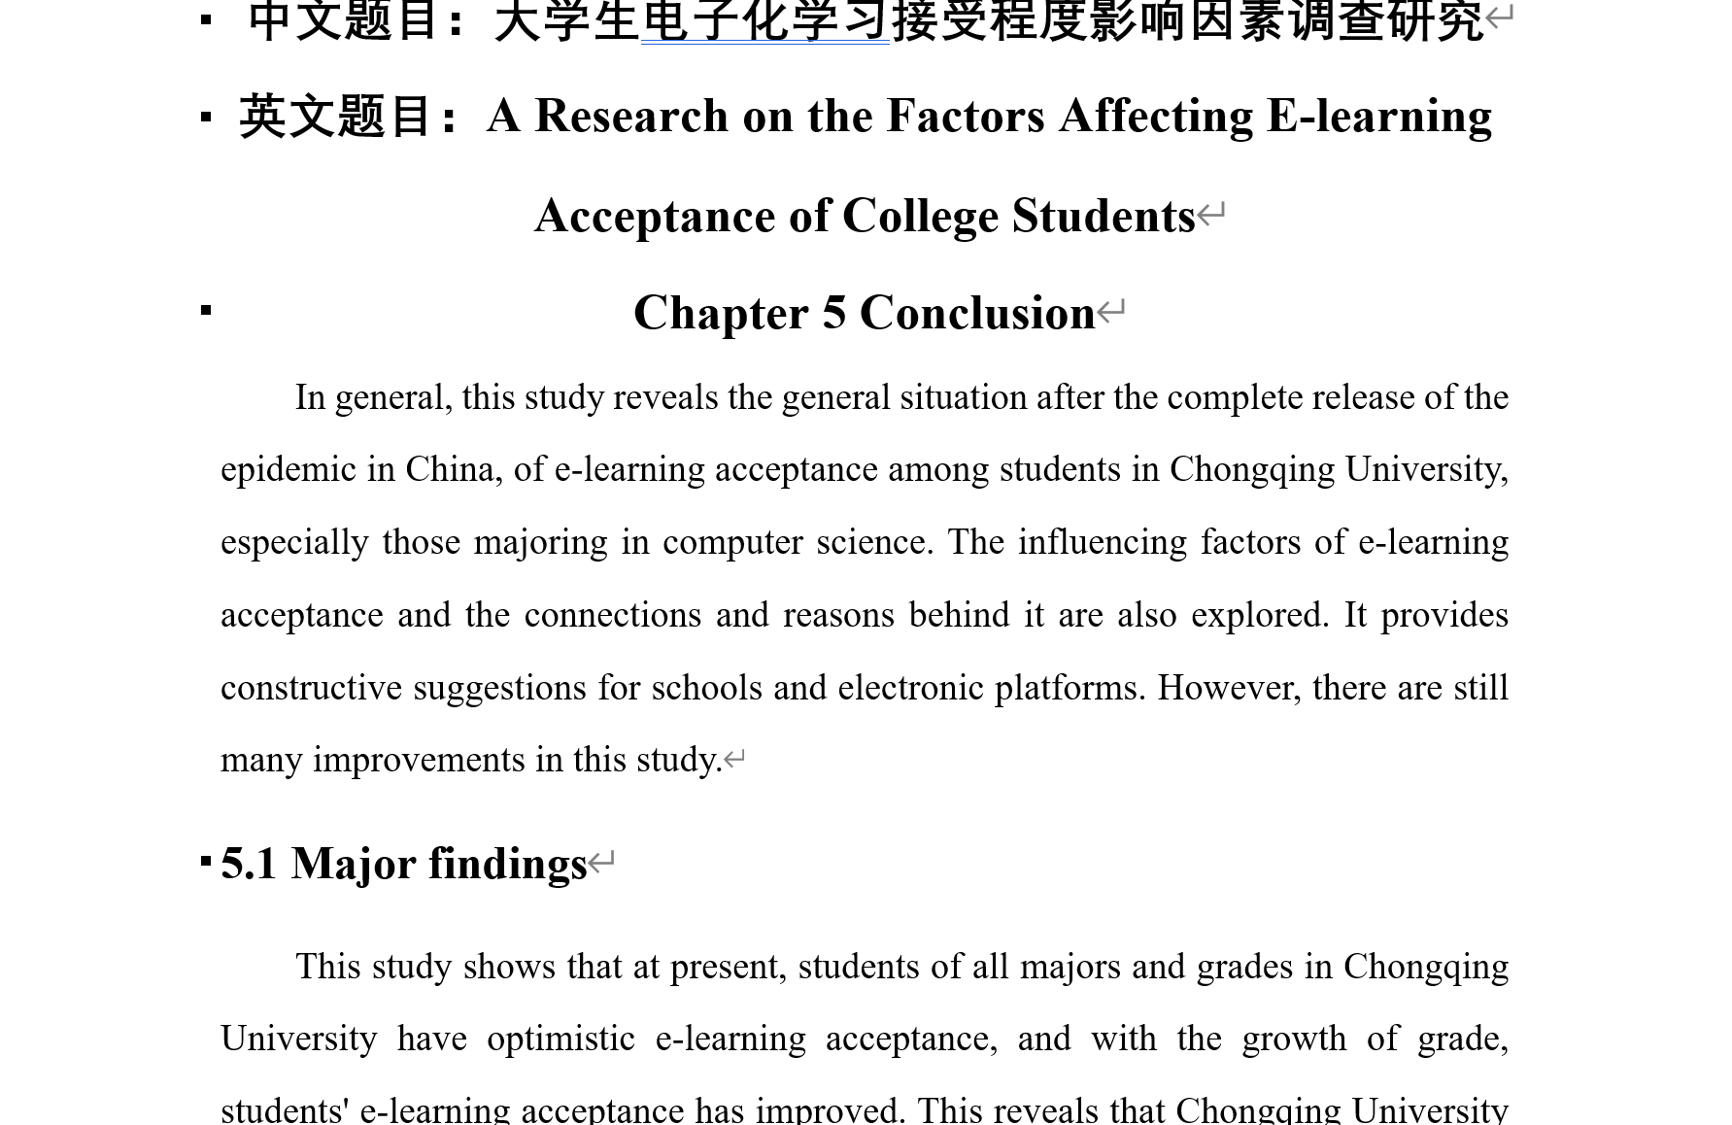

**2, Learning outcomes**

* Giving reasons when judging other teams’ presentation is appreciated.
* I can write the English research considering many aspects to make it rich.
* The implication of the research can be divided into theoretical, practical and pedagogical aspects.

**3, My behavior and attitude**

**1）Out of Class**

* Watch Ted and English movies while learning English speech.
* Browse the relevant research and literature to help me write my own research.

**2）In Class**

* Take notes while other groups were doing presentations.
* Answer questions

**4．Improvement**

English writing skills are of vital importance. I constantly use translation app to help me write English research report but I found it limited when considering the language style and humor that is important in English writing.

# Week 13

**1, My learning**

* 1. class note of week 13

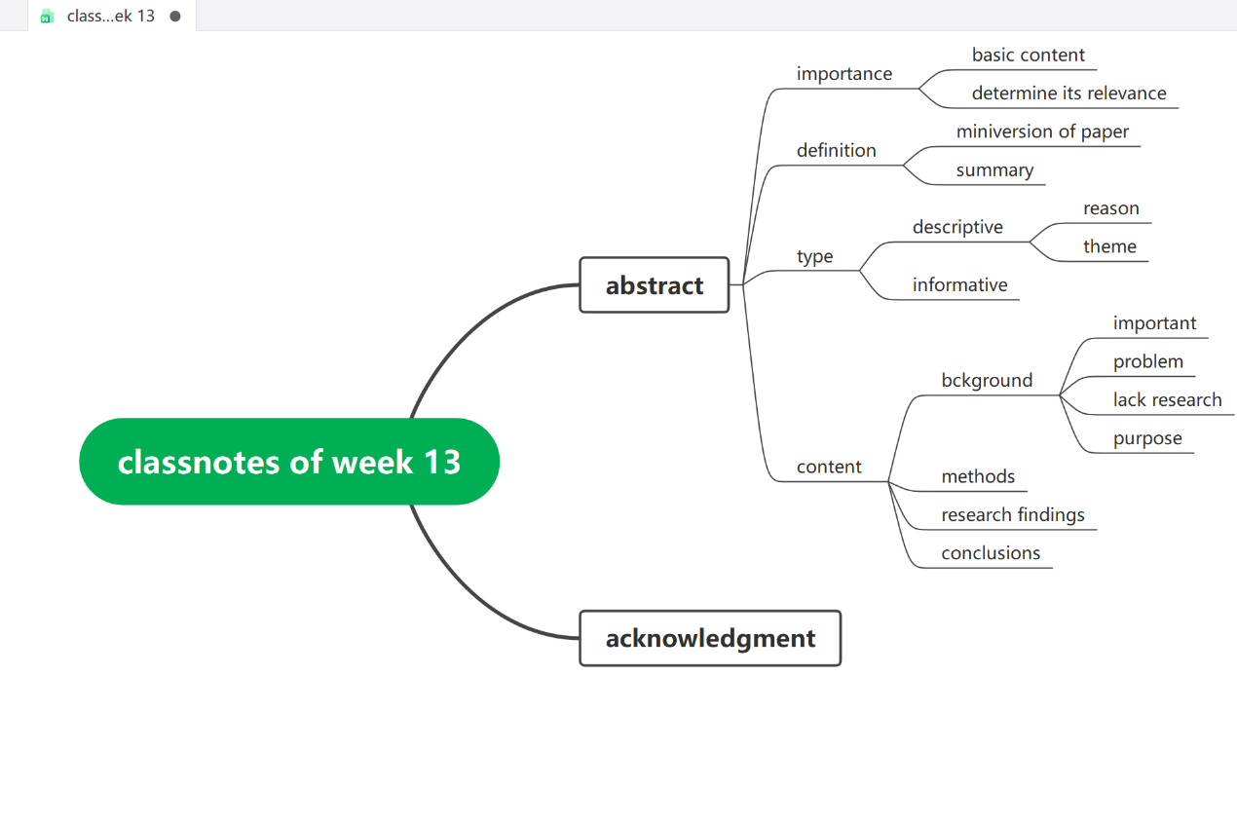

* 1. report the abstranct and key words writing

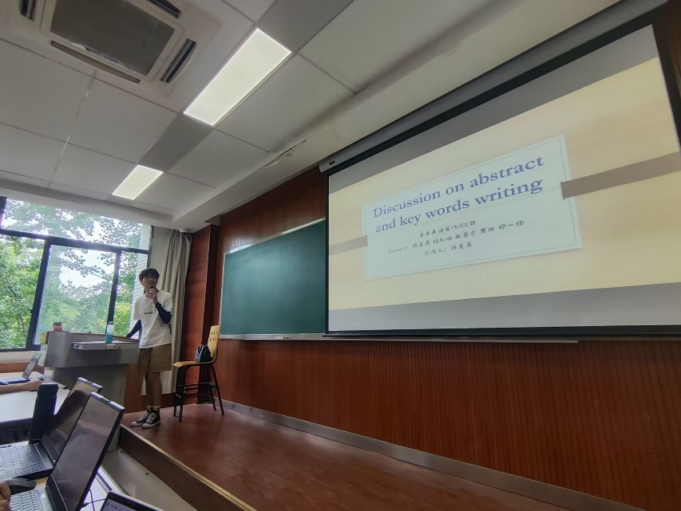

* 1. Hold the group discussion and recorde the ideas in word

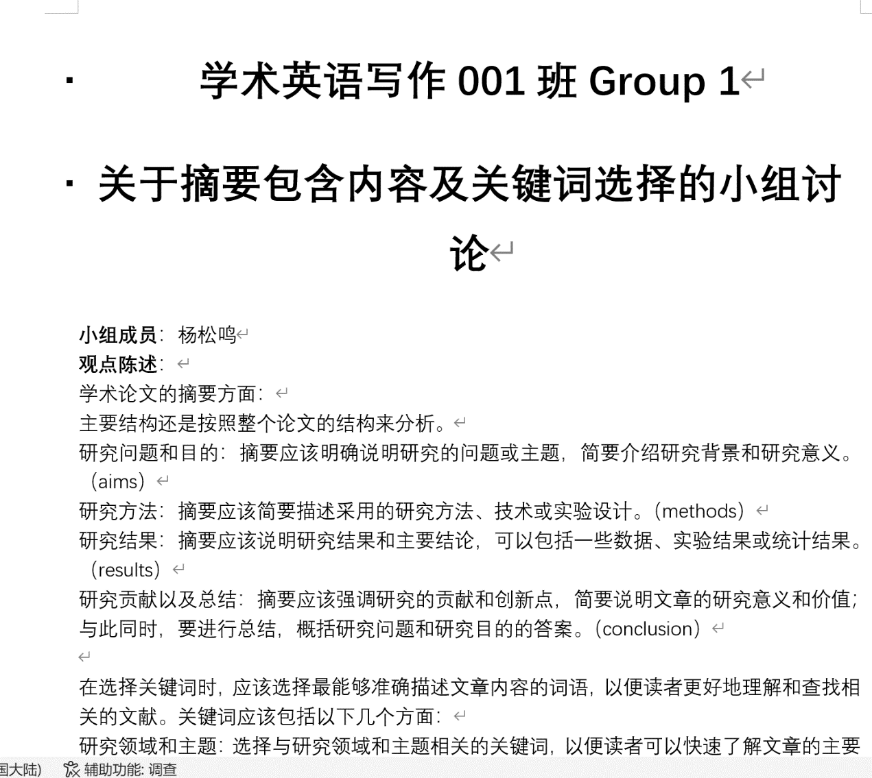

* 1. Make mind map of group discussion and presentation PPT

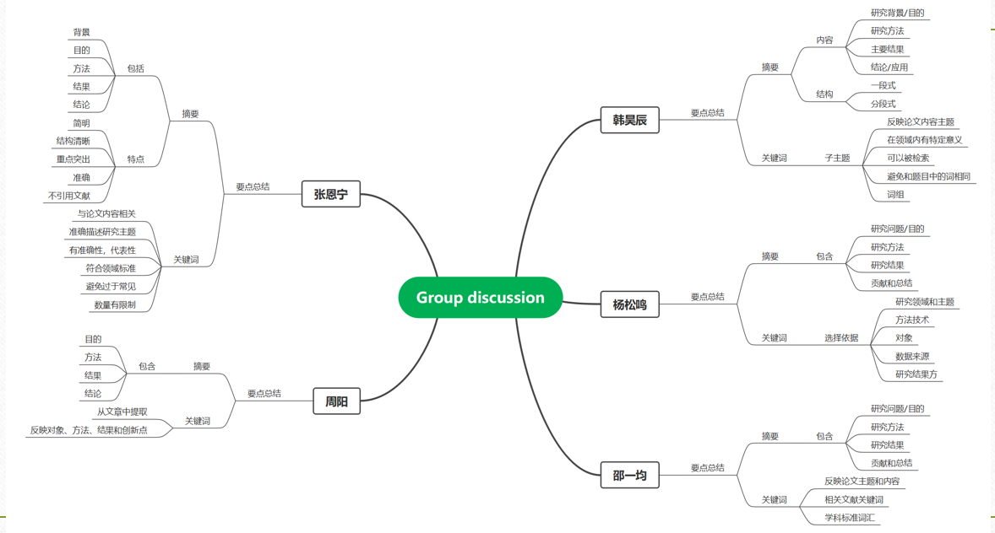

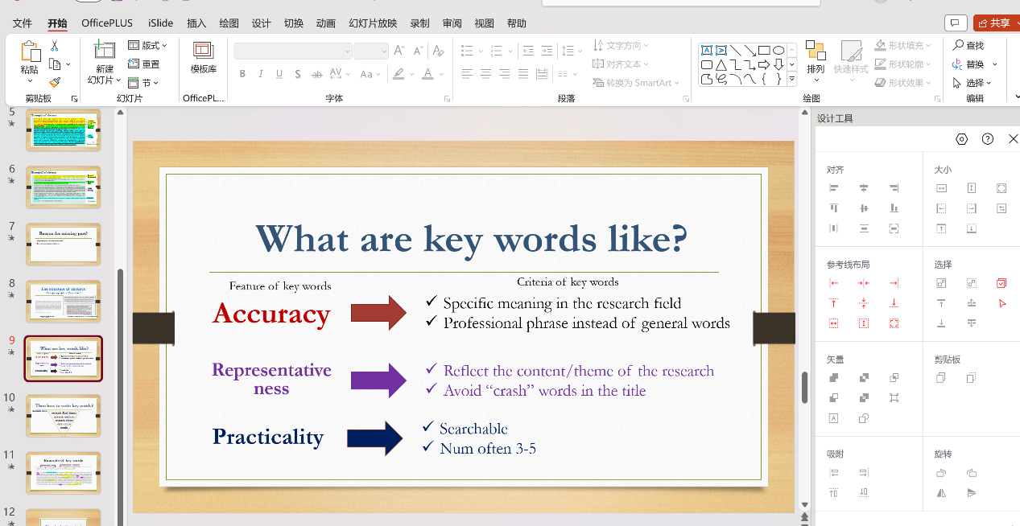

**2, Learning outcomes**

* Presentation in English is great impressive. I’ve get the highest score for our team.
* I love English.

**3, My behavior and attitude**

**1）Out of Class**

* Ted and English movies as usual. I’m always in fancy of them.
* Learn some English songs like Taylor’s Out of The Woods.

**2）In Class**

* Do the presentation
* Take notes
* Answer questions

**4．Improvement**

* English writing
* Vocabulary